WORLD REGIONAL GEOGRAPHY
GROSSMONT COLLEGE
GEO 106
THERKALSEN

REGIONAL SUPPLEMENTAL
HANDOUT PACKET FOR TEST 2
- LATIN AMERICA
- EUROPE
- SOUTHWEST ASIA AND
NORTH AFRICA
- RUSSIA

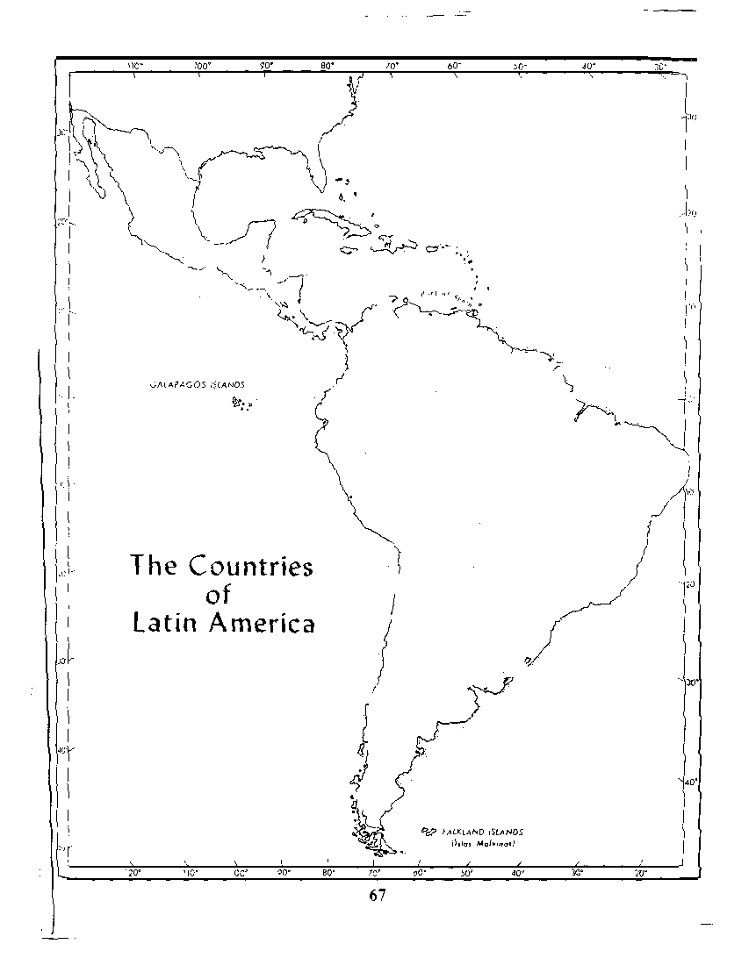
PHYSICAL GEOGRAPHY
Central Am./Western S.A.: _______________________
- Subduction =
Atlantic Side: __________________________________
- Results=
LATIN AMERICA

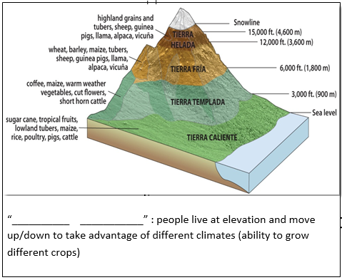

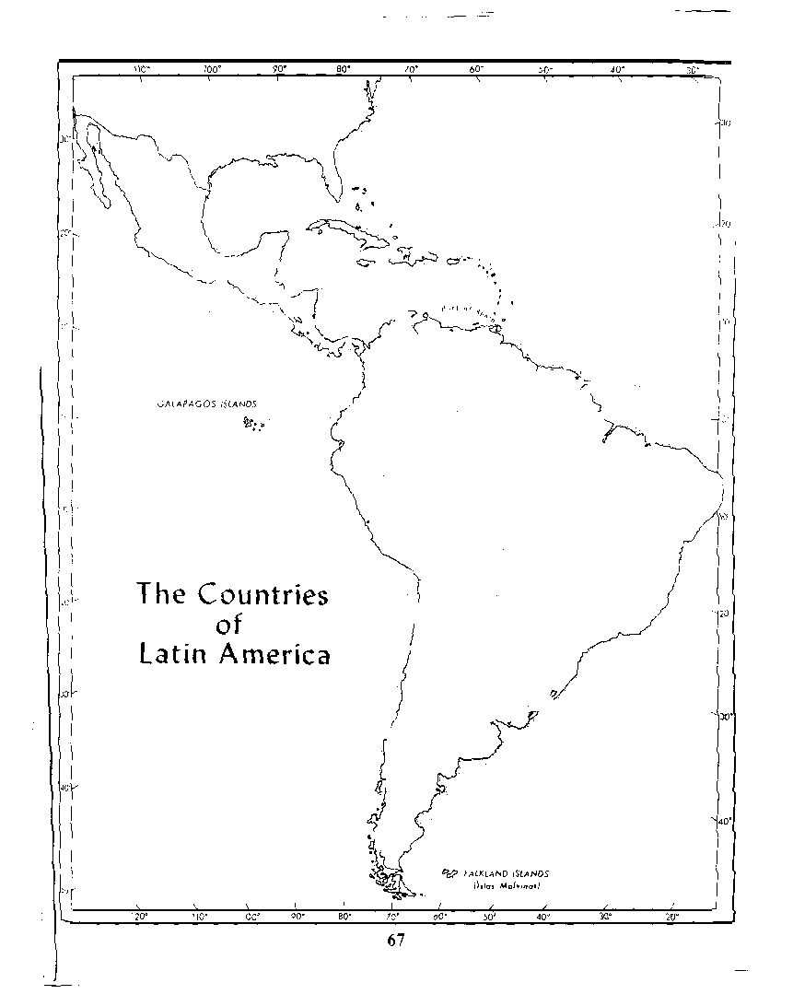
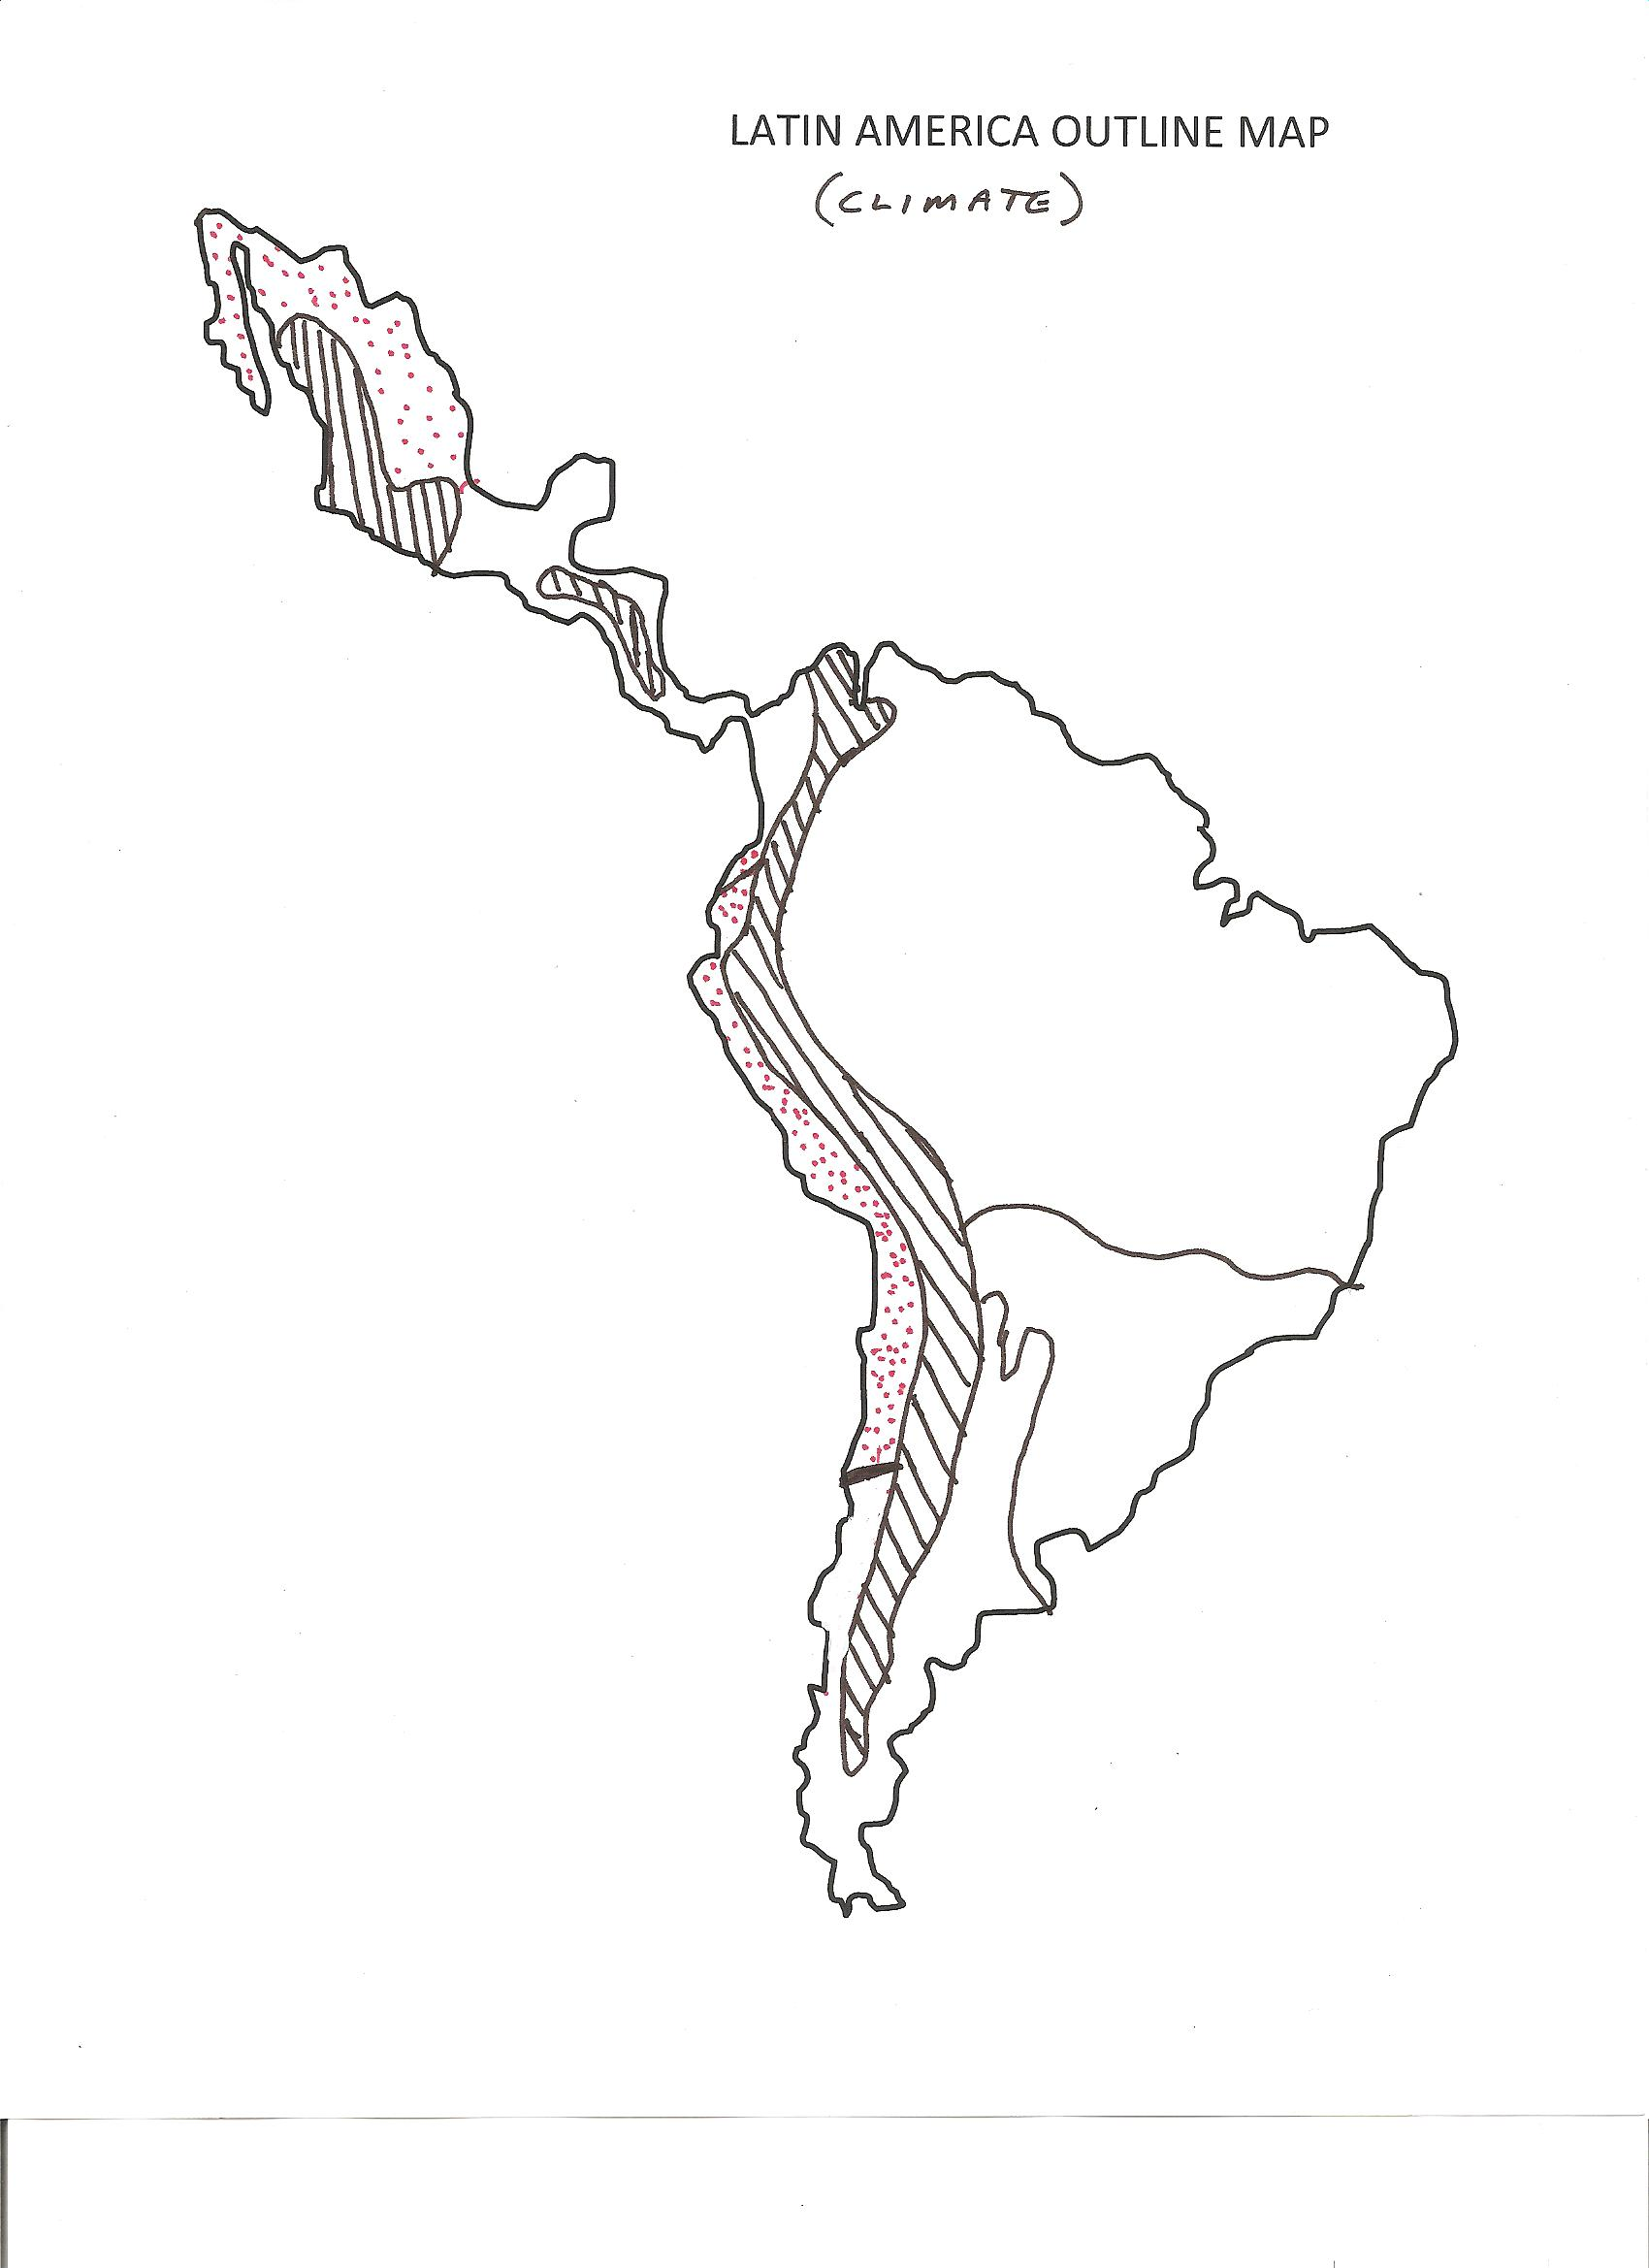

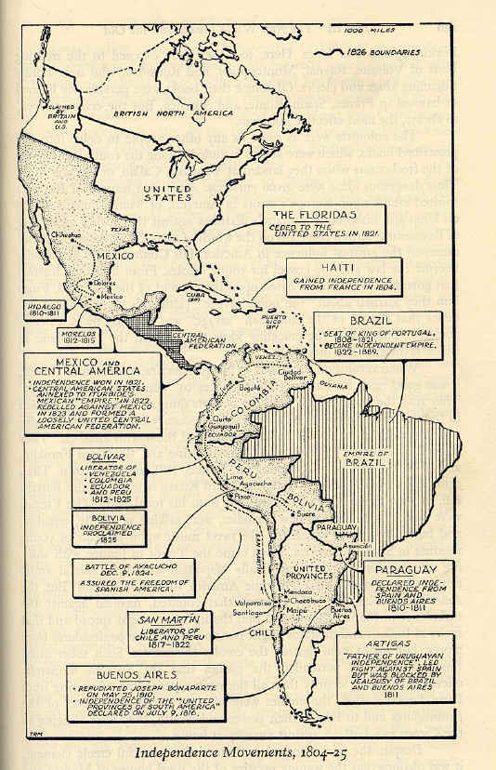
LATIN AMERICA
______________
______________

Latin American Independence: (Tied to European events)
- 1803-1815 ________________ Wars in Europe
  - ____________ Bonaparte in control of much of Spain
    - Portugal ruled from __________
- Allows Native born “_____________________” to overthrow the Spanish crown
  - Revolution by elites preserves _________________ & __________________

GEOPOLITICAL TIMELINE
EUROPE
PHYSICAL GEOGRAPHY
- Ancient ___________________ mountains; ________________ Mediterranean
- Alpine systems led to _________________ ________________________
- Central Uplands= _________________; ___________________= Population
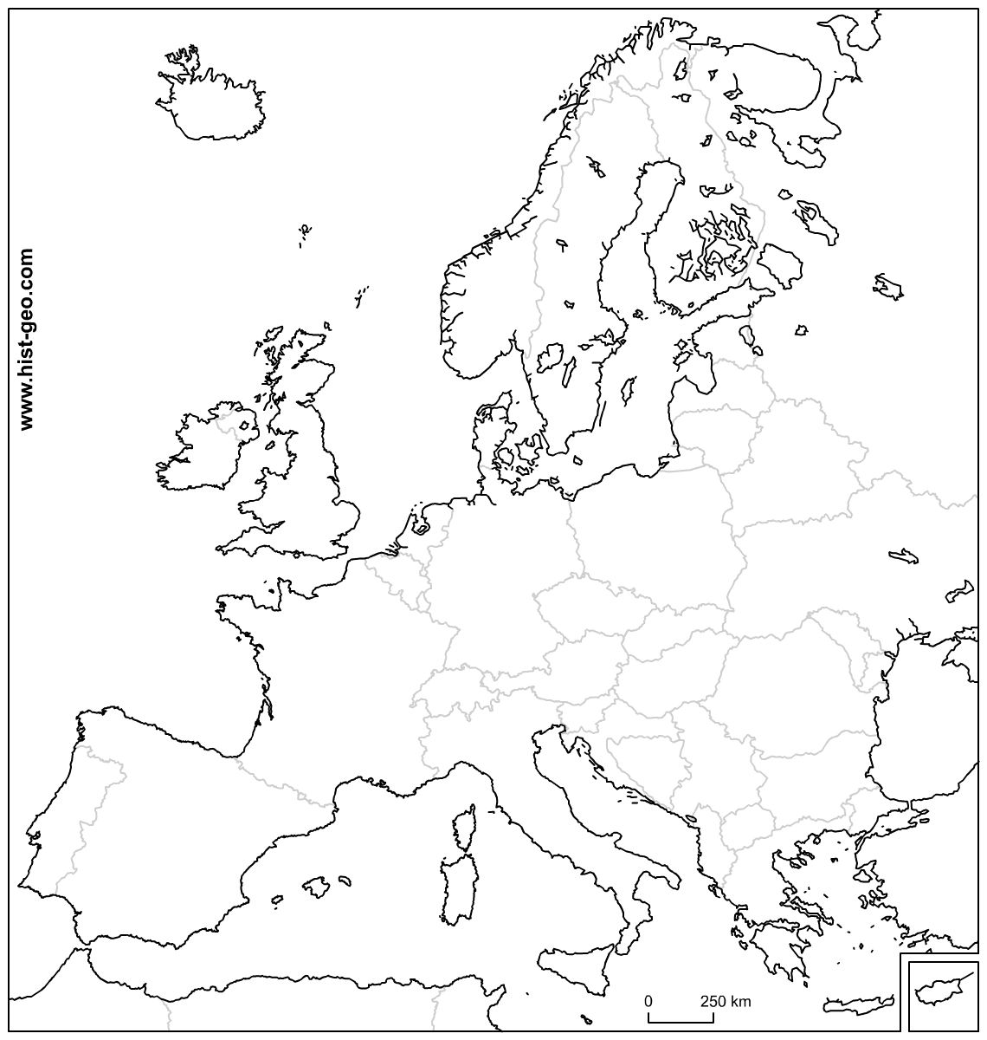
- Surrounded by ______(23,000mi coastline!); great ______ and ________ for navigation

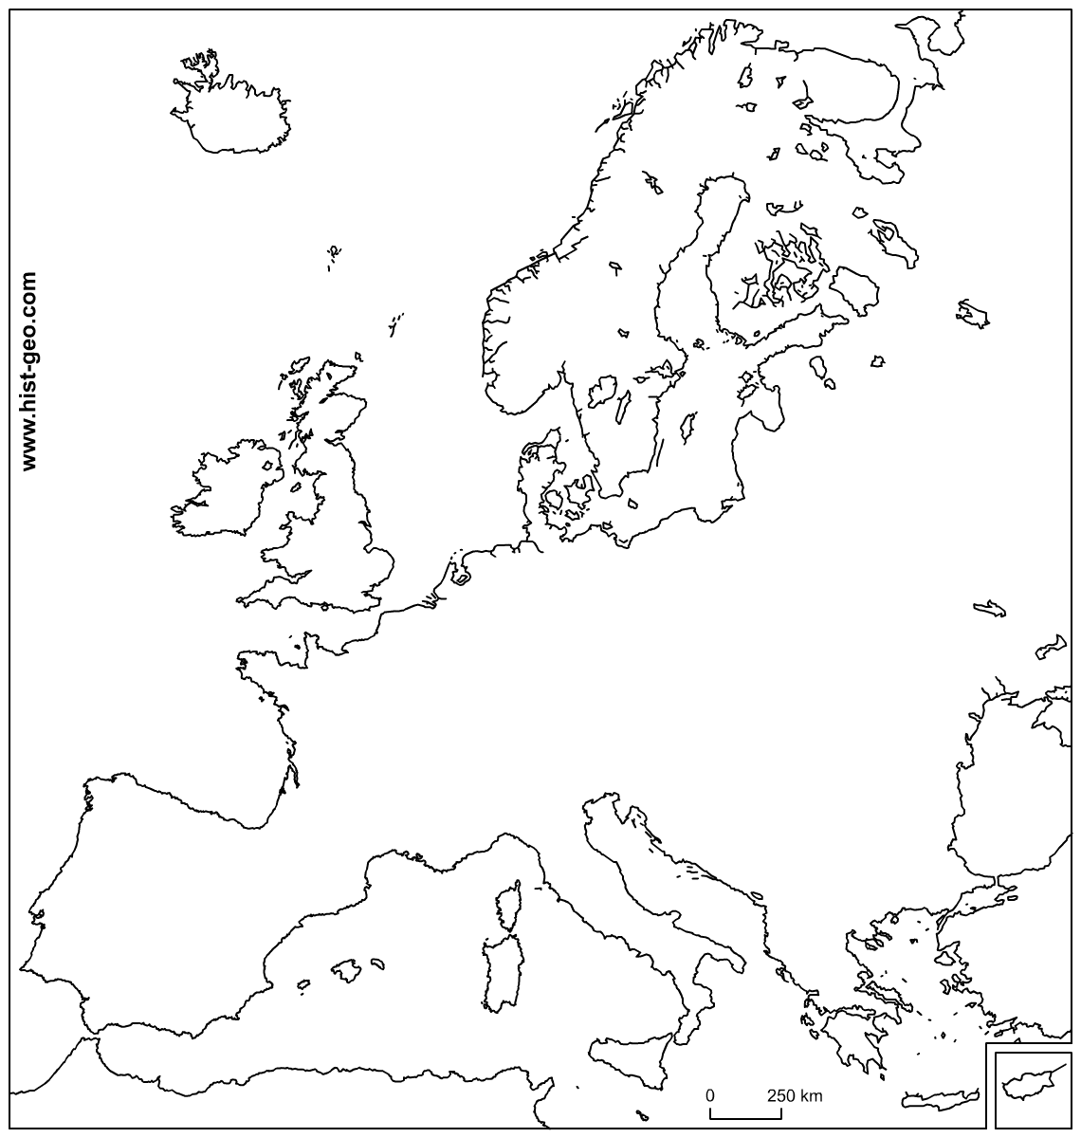
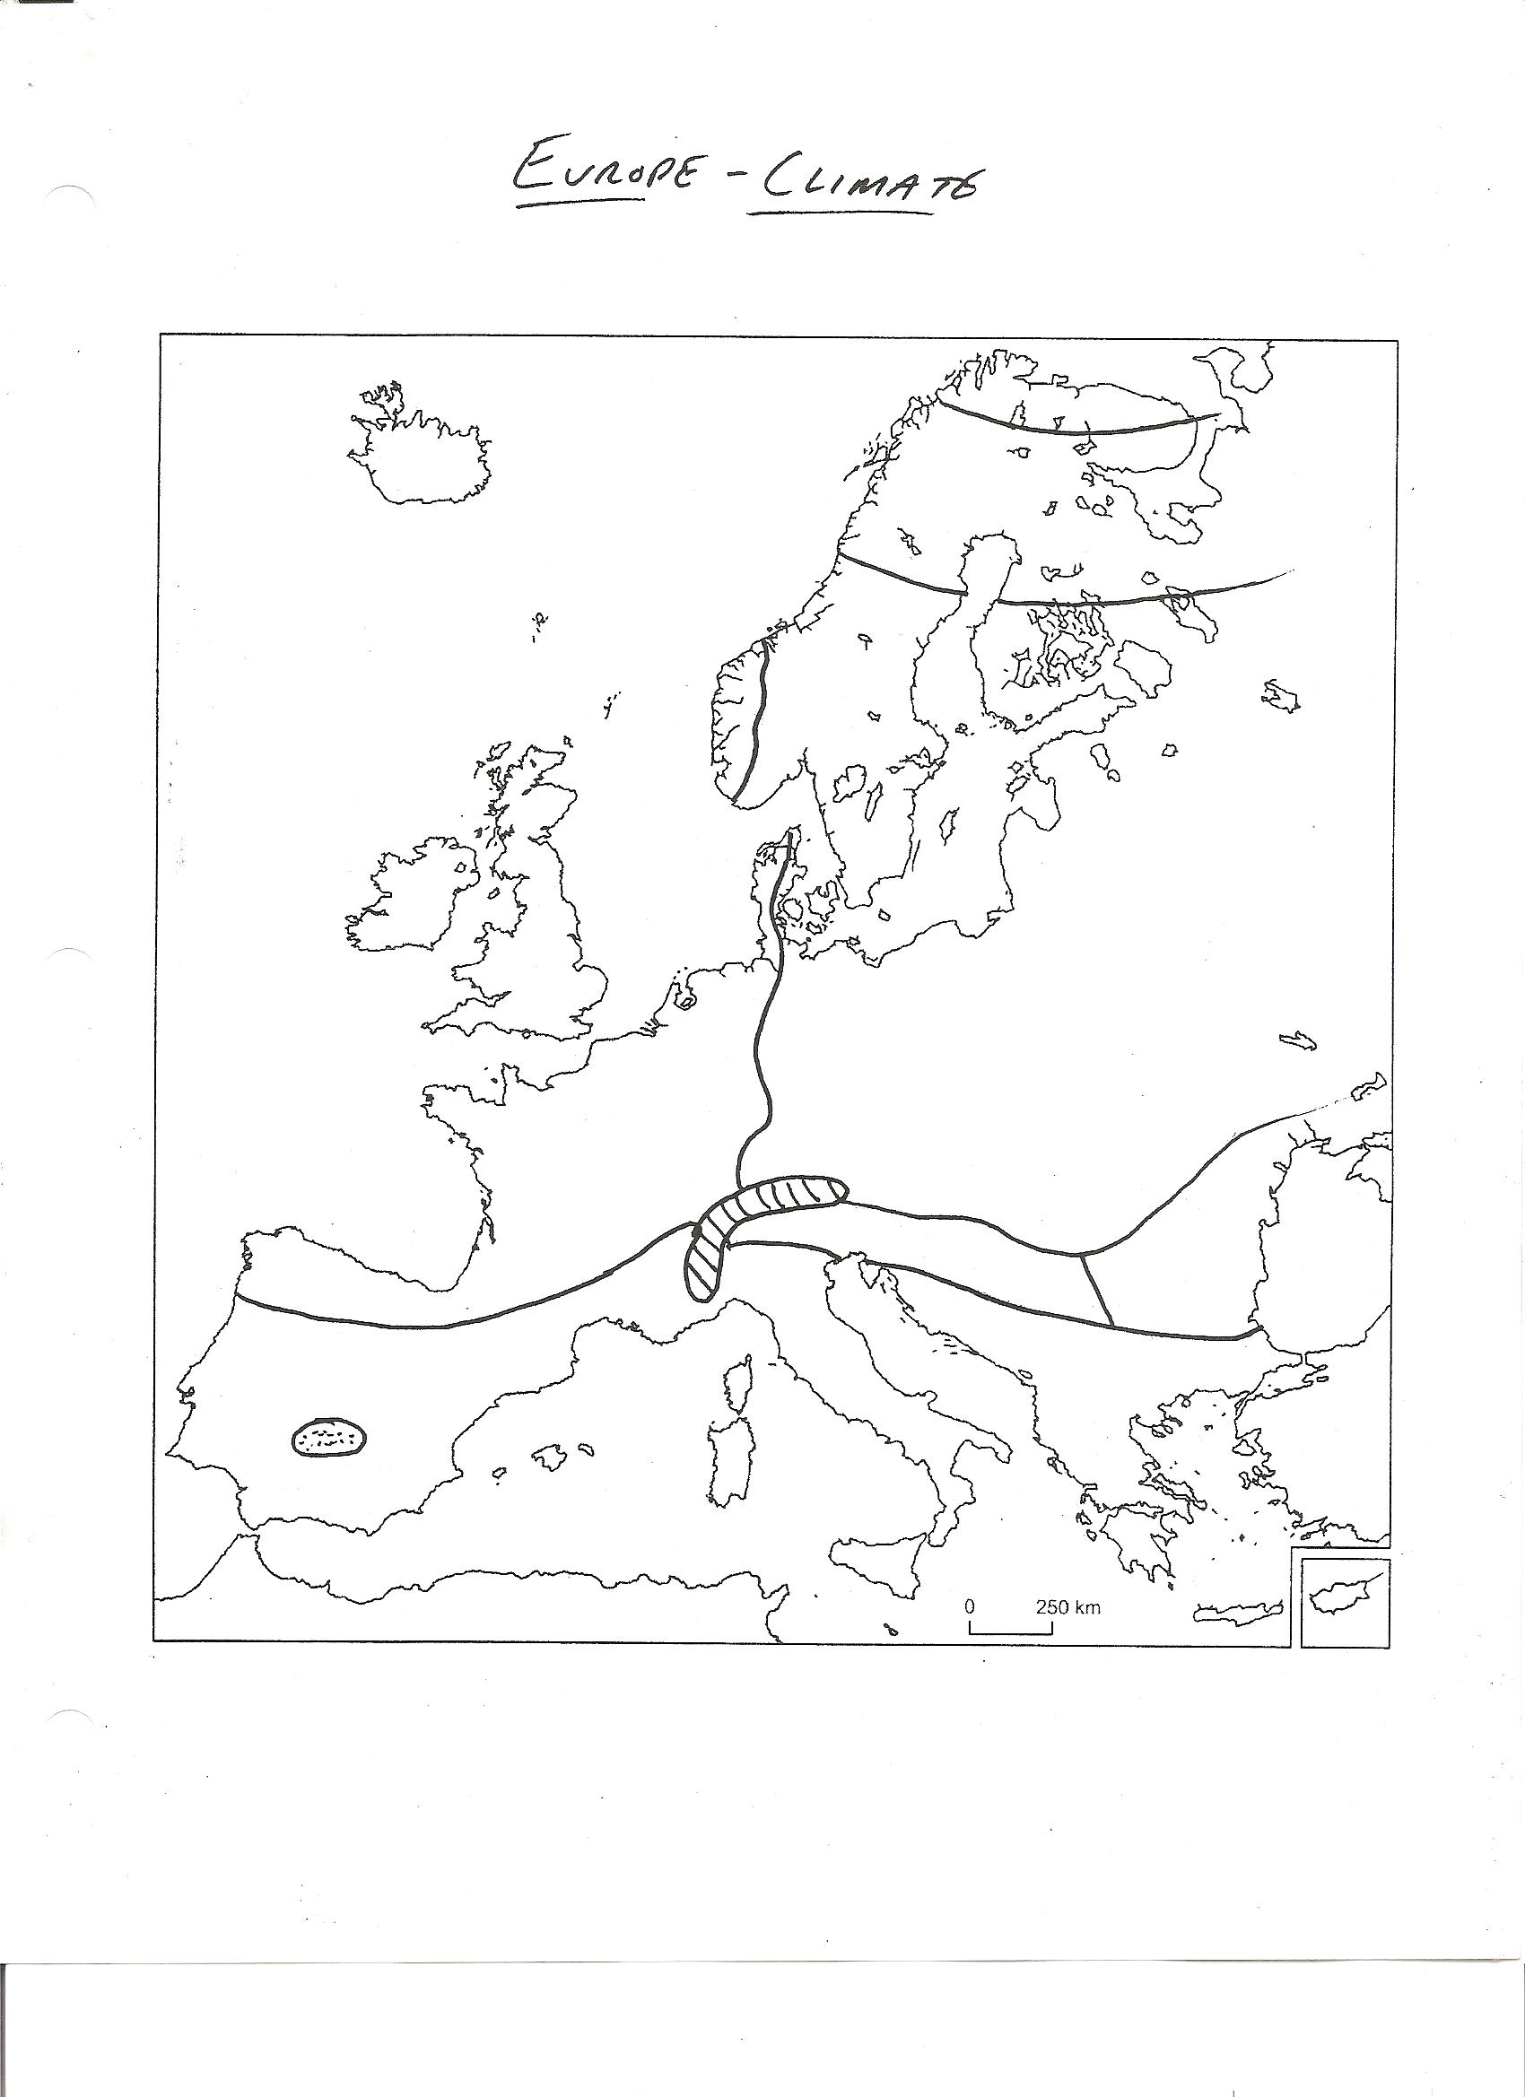
EUROPE’S CLIMATE
LATIN AMERICA
PHYSICAL GEOGRAPHY
Central Am./Western S.A.: _______________________
- Subduction =
Atlantic Side: __________________________________
- Results=

LATIN AMERICA CLIMATE MAP
EUROPE

1930’s Global Depression – 3 solutions
1. Western solution:
2. Soviet Solution: __________________ - “ a system based upon a classless society where people own the means of production”
3. Germany/Italy solutions: ____________________________
“A system that values __________ over the ___________ (State has complete control) Escalation leads to _________

WWI _________

VS
France, Britain and Russia
Cause: _____________ of heir to Austro-Hungarian throne; domino effect of ___________ of allegiances

1919 Treaty of _____________

Results:___________ broken up
Austro-Hungarian =
Ottoman Empire =
Germans =
Russia withdrew ______ (Oct. Rev) = Ind. Countries:
Finland, Estonia, Latvia, Lithuania, and __________

GEOPOLITICS
EUROPE

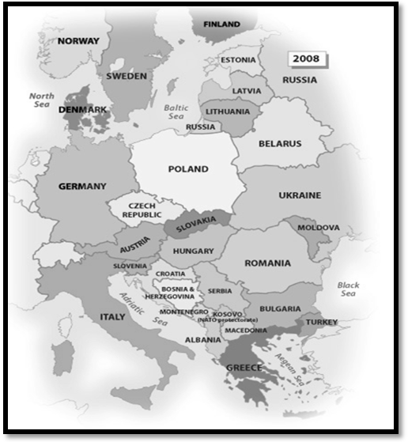
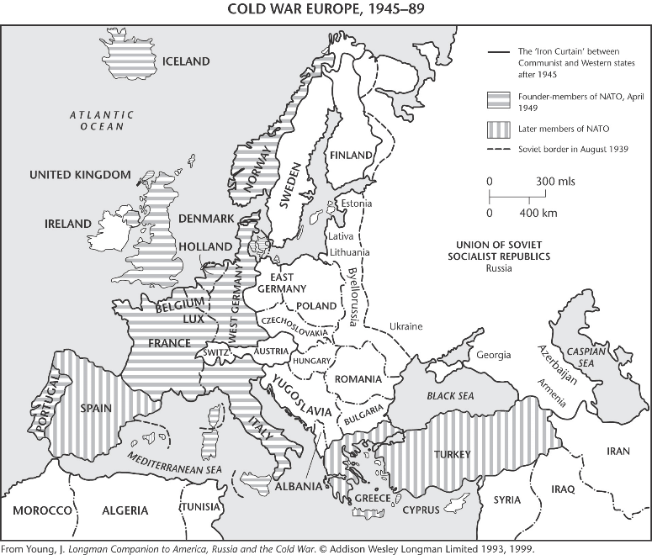
WWII __________
Cause: ____________ agression in Europe
AXIS:
VS
ALLIES:
Won largely by: ______________
Post WWII – New superpower (______)
New borders; New conflict:
_______ War (1945-_______)

VS

End of Cold War
1989: signaled by fall of _____________ ; later USSR acceptance
Former USSR states: Estonia, Latvia, _____________, __________, __________, Moldova, “Caucuses States” and the “__________”
Yugoslavia: ___________ cleansing = _______ states
Slovenia, _________, Bosnia and Herzegovina, Montenegro, Macedonia, _________ and ____________

EUROPE

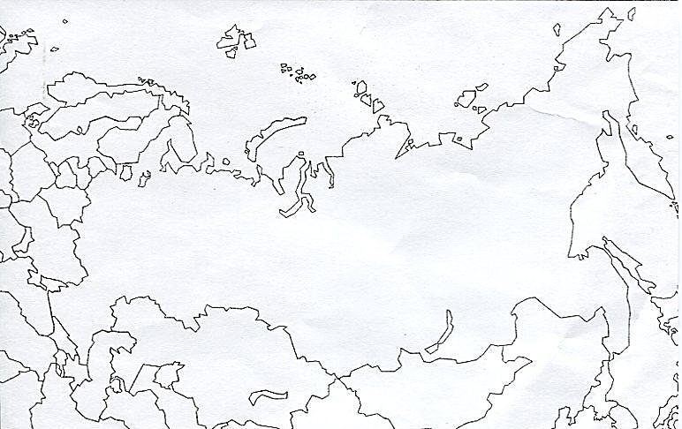
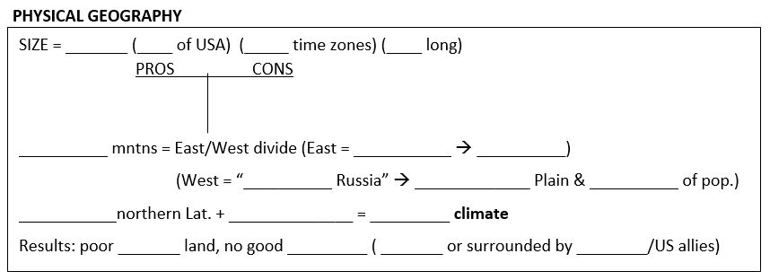
RUSSIAN DOMAIN
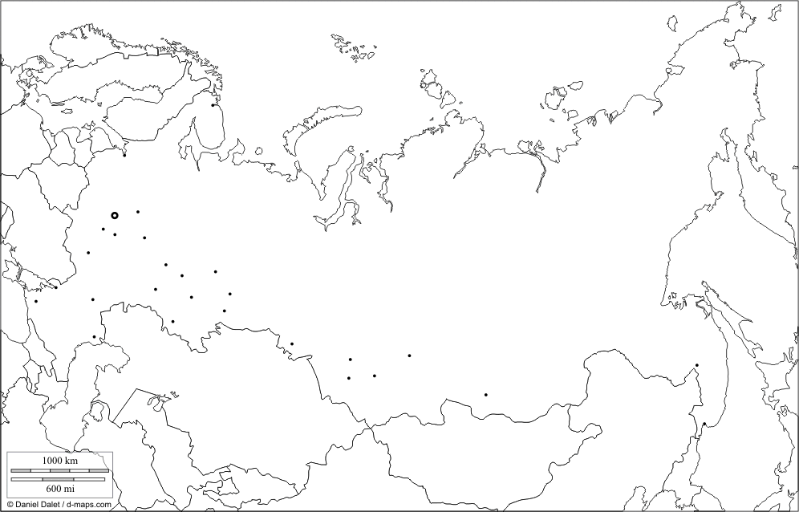
POPULATION
* Moscow: “ _______” of Russia (_____m)
- ___________ city
* St. Petersburg (history of name changes) (____m)
- Important _________
- Former “________________” (1712-1917)

RUSSIAN EXPANSION
Huge _______________ Territory
- Requires _____________ control
RUSSIAN DOMIAN
T1 -
T2 - 14th-16th century:
T3 – 1500-1800’s:
1700’s:
1800’s:
T4 – 1917:
T5 – Post WWII:
1991 – Fall of USSR :
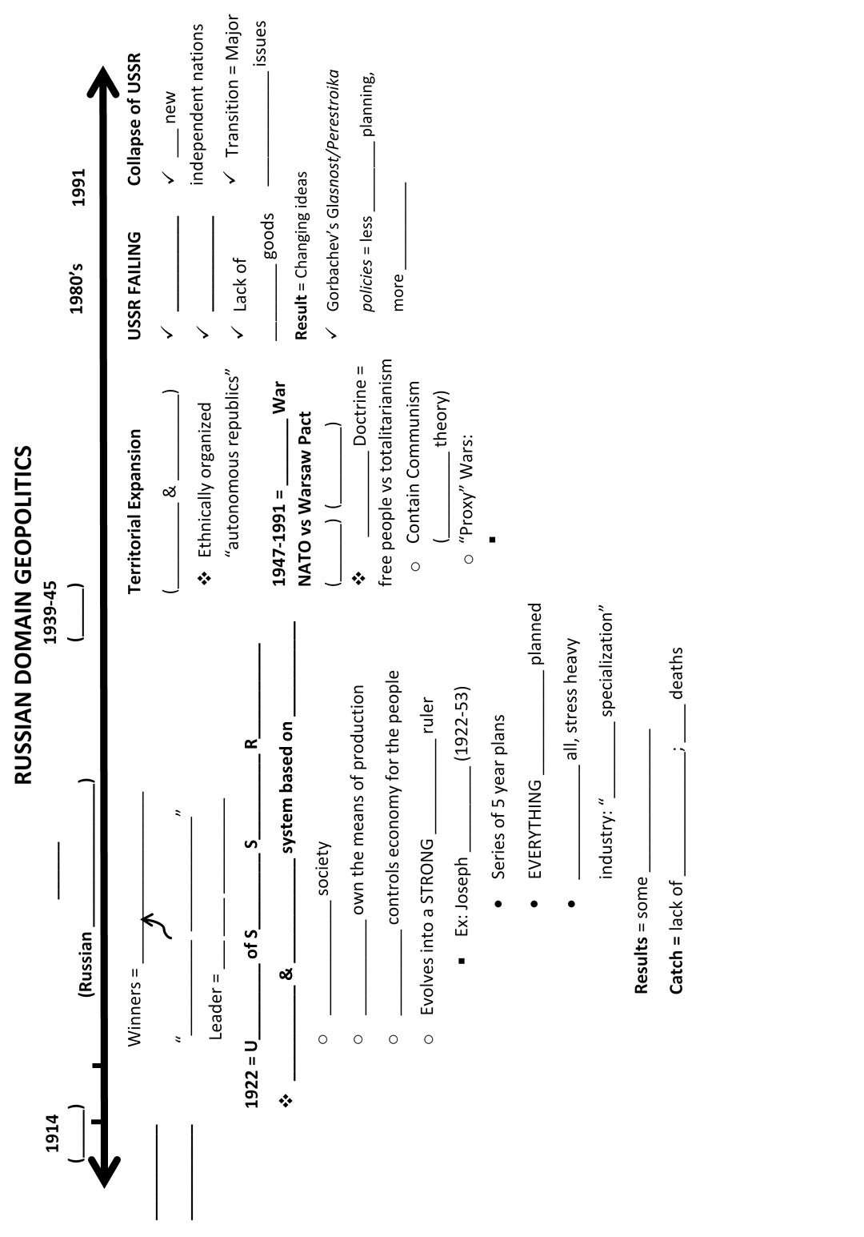

Sw asia and north Africa

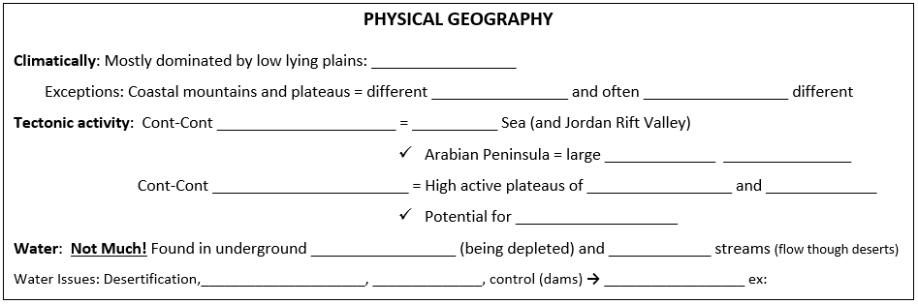

The Holy Lands
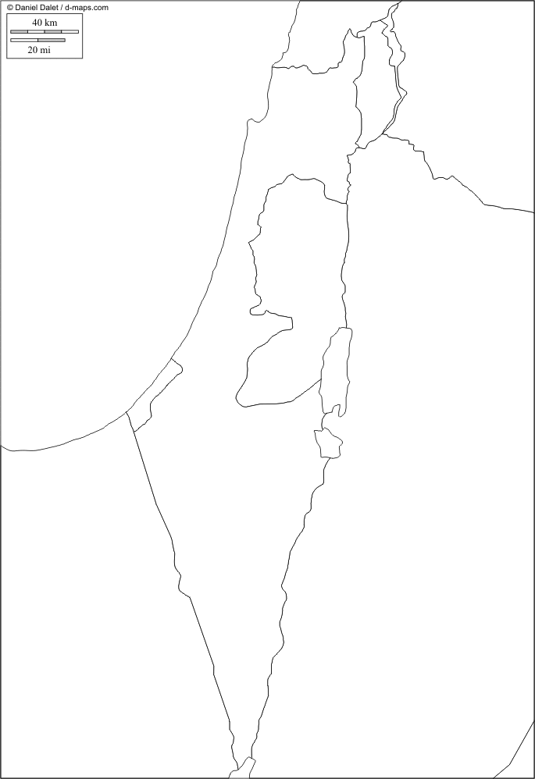
Historically known as Palestine* today called the country of __________
(*The mostly __________ descendants of people populating lands are called: _________________ )
Jerusalem Holy Sites
1. Christianity: Church of the _______________ (where __________ was buried and resurrected)
2. Judaism: ___________________ (all that’s left of great Temples)
3. Islam: ___________________________* (from whence _____________ ascended to Heaven) *Also Holy for other two

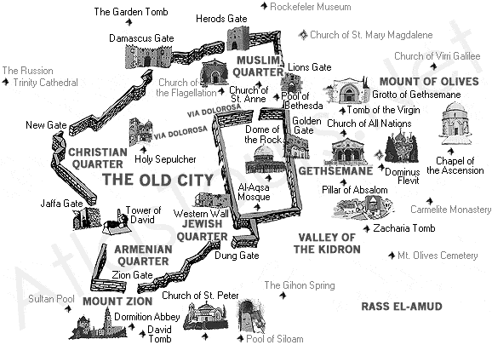

Timeline of Key Events:
1500’s-1919: _____________ Empire (__________) Post WWI = _____________ Mandate
Post WWII: British pull out CREATING new country of ___________
UN PARTITION plan = 1 _________ State & 1 _________ State (Jerusalem administered by _____)
Immediately leads to ________, conflict, and more ________*
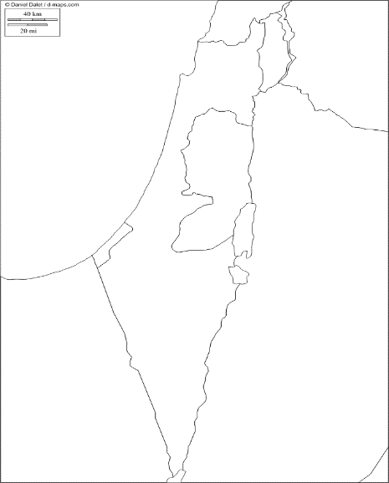
→ Usual parties: ________ vs _________. _________. _________ Usual winner:
TODAY (results of 1967 war)

*KEY WAR: ________ “6 Day War” – Same Parties
Same Results: __________ Wins
Israel gains:

GEOPOLITICS
PRE-WWI: ________________Empire Dominant
Persia (________) = independent kingdom (with ______ “involvement”) until _________ revolution establishes a _____________ (rule by _______). → tension with neighbors and __________
DURING WWI: British promise the same territories to _________, ___________, _________ and themselves
RESULTS OF WWI
- ____________ Empire loses territory and becomes ___________ taking potential state of ____________
PROMISES:
- ARABS: King Hussein gets Arabian Peninsula from British but it is quickly taken over by Ibn-Saud who creates the kingdom of ____________ ___________ based on the Islamic sect of _____________
- FRANCE: gets mandate to control ____________ and _____________
- BRITAIN: gets mandate to control : _________, ______ and __________ (Inserts Kings Hussein’s sons as Kings of Iraq and Jordan)
- JEWS: start to move and establish Jewish homeland in Palestine.
NORTH AFRICA→ Colonial powers were __________, ____________, and Italians
RESULTS OF WWII: ___________________
GENERAL RESULTS OF COLONIAL ERA TODAY: Kleptocratic _______________ and _______________
THUS CONSTANT ________________. Ex:
__________

LATIN AMERICA REVIEW QUESTIONS
Sw asia/
n.africa
1. What are the 5 basic introductory points to know about Latin America?
2. Explain the Physical Geography of Latin America:
- Explain the general physical geography (the blanks we filled in)
- Describe the specific physical features we noted in class, their formation (where applicable) and their importance
- Be able to locate these important features on a map
- Describe the general climate patterns found throughout the region (explain the basic reasons for the different climates using the 5 variables from class)
- How does the physical geography explain the other themes (e.g. population distribution, agricultural/economic activity, etc.)
3. What is Altitudnal Zonation? How does it help explain population distribution in LA?
4. Where are the majority of people in LA concentrated and why?
5. What stage of the DTT was LA in prior to the 1980’s, what stage is it in today and why the change? (who’s the exception?)
6. Explain how “land use” in Latin America has changed since colonial times. For what reasons is LA almost “fully urban” today and what are the problems associated with this urbanization trend?
7. Explain the Latin American city model? How does it differ from the US model? What are the major issues facing urban Latin America today?
8. What did pre-Columbian culture in the Americas look like (numbers, major civilizations, locations, complexity, etc.)? How did this change with the arrival of Columbus?
9. How did the culture of Latin America change with the arrival of the Spanish and Portuguese (Language, religion, etc.)? What was the class structure that evolved out of Iberian conquest? How does it influence life today?
10. Describe the exchange that took place between the old world and the new world (export/import of animals, foods, goods).
11. What was the Treaty of Tordesillas? What were the “3 G’s” Spaniards were after?
12. When/why/how did nations of Latin America gain independence and what has been the political situation since independence?
13. Compare Latin America to the rest of the world in terms of “development.”
14. Explain the historical economic transitions throughout Latin America (i.e. what was the strategy and problems pre-1980’s and today?)
EUROPE REVIEW QUESTIONS
1. What are the 5 basic introductory points to know about Europe?
2. Explain the Physical Geography of Europe:
- Explain the general physical geography (the blanks we filled in)
- Describe the specific physical features we noted in class, their formation (where applicable) and their importance
- Be able to locate these important features on a map
- Describe the general climate patterns found throughout the region (explain the basic reasons for the different climates using the 5 variables from class)
- How does the physical geography explain the other themes (e.g. population distribution, agricultural/economic activity, etc.)
3. What stage of the demographic transition theory is Europe in? What are the problems and solutions associated with this fact?
4. How has urban planning of Europe changed over time (why are so many located on rivers? What does a medieval city look like compared to a renaissance city, is today’s European urban model the same as the US (suburbanization) and why?)
5. What language family do most Europeans speak? Compare and contrast the major language branches of Slavic, Germanic and Romance (number of speakers, locations, alphabet, etc).
6. What is the major religion of Europe? How did it spread? What new branches have evolved where and why?
7. Describe the spatial distribution of culture in Europe (north vs. south vs. east Europe)
8. What role has Islam had within Europe historically and today?
9. Explain the impact of WWI on the landscape of Europe. (who was involved, who won, what was the outcome of the final treaty, what new states were created, etc.)
10. What happened during the 1930s that led to the emergence of new political/economic philosophies? What were those philosophies? Who were those leaders?
11. Explain the impact of WWII on the landscape of Europe. (who was involved, who won, what new states were created, etc.)
12. What was the Cold War all about? (who was involved, what were the competing ideas, what impact did it have on the world?)
13. What the heck is going on with the Balkan region (when was the country of Yugoslavia created, when did it start to break up and for what reasons?)
14. Explain the economic timeline of Europe from the Industrial revolution through the EU.
15. Compare and contrast the rebuilding of Eastern and Western Europe after WWII and the results.
Add the following to your timeline:

- Classical Greece (500BCE-300BCE)
- Roman Empire (500BCE-400CE)
- Eastern Roman Empire (AKA: Byzantine Empire) (400-1453)
- Medieval period
- The Renaissance

- Protestant Reformation
- Industrial Revolution
- World War I and II
- Cold War
- “Great Schism” Eastern Orth.
- Berlin Conference

RUSSIAN DOMAIN REVIEW QUESTIONS
1. What are the 5 basic introductory points to know about the Russian Domain?
2. Explain the Physical Geography of the Russian Domain:
- Explain the general physical geography (the blanks we filled in)
- Describe the specific physical features we noted in class, their formation (where applicable) and their importance
- Be able to locate these important features on a map
- Describe the general climate patterns found throughout the region (explain the basic reasons for the different climates using the 5 variables from class)
- How does the physical geography explain the other themes (e.g. population distribution, agricultural/economic activity, etc.)
3. Where does the majority of the Russian population reside? What factors explain this pattern? What’s causing the growth of the cities of Siberia today?
4. How has population changed (grown or shrank) pre and post USSR and why?
5. What are the migration patterns pre and post USSR?
6. What does the Russian city model look like and which are the most important cities?
7. Explain the historical “cultural/territorial expansion” of Russia.
8. What is dominant language and religion of the Russian Domain today and how did this change pre and post USSR?
9. Explain the geopolitical development from the Russian empire through the USSR to the current day?
- What were the dominant ideologies? Who were the leaders?
- What political/economic systems and plans were used?
- How did territory expand?
- What’s happening today?
10. How has economic, social, and environmental development of the region changed during and post the USSR? What have been the results?

NORTHERN AFRICA AND SOUTHWEST ASIA
1. What are the 5 basic introductory points to know about N.Africa/SW Asia?
2. Explain the Physical Geography of N.Africa/SW Asia:
- Explain the general physical geography (the blanks we filled in)
- Describe the specific physical features we noted in class, their formation (where applicable) and their importance
- Be able to locate these important features on a map
- Describe the general climate patterns found throughout the region (explain the basic reasons for the different climates using the 5 variables from class)
- How does the physical geography explain the other themes (e.g. population distribution, agricultural/economic activity, etc.)
3. What are the general population characteristics of the region (numbers, TFR, LE, )? Where does the majority of the population reside? And what are the density patterns in the region?
4. What are the migration patterns of the region?
5. What language family is mainly spoken? (others?)
6. Briefly explain the evolution of the Latin alphabet from it’s roots in Cuneiform.
7. Explain the Abrahamic family tree and the religions evolved from it.
8. What are the “5 pillars of Islam?” What caused the split between Sunni and Shias? Where are they distributed today?
9. What’s the deal with Jerusalem? Who wants the holy lands and what 3 major important places did we discuss? Explain the basic history of land political boundaries from class. Who controls what lands today?
10. What other religious issues does the region confront?
11. Explain a simple evolution of the political borders of the region (Ottomans through today).
12. Place the countries on the “development line” from class and explain why they fall where they do. What major resource is tied to development, how does it influence GDP/Capita?
13. What social issues does the region face?
14. What environmental issues does the region face?
